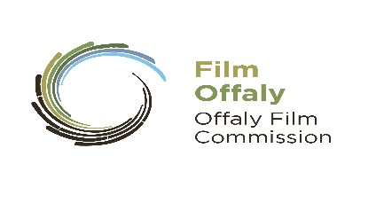

FilmOffaly Short Film Award 2019 Application Form

One Application Form needs to be submitted with the script.
Only one script per author. Read Guidelines Carefully.

Closing date 3pm Friday 22nd March 2019

Post Application Form (not e-mail) together with three copies of your script
and three copies of a 500-word synopsis to:
FilmOffaly Short Film Award, Arts Office, Offaly County Council, Aras an Chontae, Charleville Road, Tullamore, Co. Offaly

Details: (IMPORTANT PLEASE COMPLETE IN BLOCK LETTERS)
Applicant Name:
Applicant Address:

Telephone:
Mobile:
E-Mail: (Please Print Clearly)
Website:
Name of Script
Name of Writer/Writers
Contact of Writers (Tel or Mobile):

Production Company/Producer (If Known)
Name & Contact Number
Production Company Address (If Known)
Director and/or DOP (If known)

Type of Script | Short Fiction Short Documentary Experimental
Enclosed (Check List)
Three Copies of Script or Treatment (In case of documentary)
Omit authors and production companies name from Script.
Three Copies of Synopsis
Declaration:
Signed: Dated:
Important Notes: Please read the Guidelines carefully before submitting your script.
-Scripts will not be returned if a S.A.E of correct size and postage is not supplied.
-Applications will not be accepted after the deadline.
-All entries must be posted or delivered by hand. Not by e-mail.
-We do not accept CDs or removable drives.
- Please complete all sections of this application form. You will be notified by e-mail of decisions

