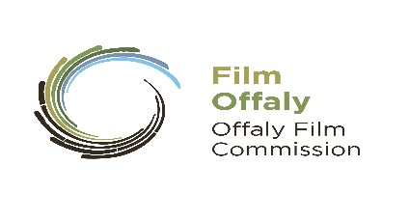
FILMOFFALY SHORT FILM AWARD 2020

APPLICATION FORM

An Application Form needs to be submitted with the script.
Only one script per author.
NB Omit author name and production company from script only title & length accepted
Read Guidelines Carefully.

Closing date 3pm Friday 20th March 2020

Post Application Form (not e-mail) together with two copies of your script
and two copies of a 500-word synopsis to:
FilmOffaly Short Film Award, Arts Office, Offaly County Council, Aras an Chontae, Charleville Road, Tullamore, Co. Offaly

Details: (IMPORTANT PLEASE COMPLETE IN BLOCK LETTERS)
Applicant Name:
Applicant Address:

Telephone:
Mobile:
E-Mail: (Please Print Clearly)
Website:
Name of Script
Name of Writer/Writers
Contact of Writers (Tel or Mobile):

Production Company/Producer (If Known)
Name & Contact Number
Production Company Address (If Known)
Director and/or DOP (If known)

Type of Script | Short Fiction Short Documentary Experimental
Enclosed (Check List)
Two Copies of Script or Treatment (In case of documentary)
Omit authors and production companies name from Script.
Two Copies of Synopsis
Declaration:
Signed: Dated:
Important Notes: Please read the Guidelines carefully before submitting your script.
-Scripts will not be returned
-Applications will not be accepted after the deadline.
-All entries must be posted or delivered by hand. Not by e-mail.
-We do not accept CDs or removable drives.
- Please complete all sections of this application form. You will be notified by e-mail of decisions

