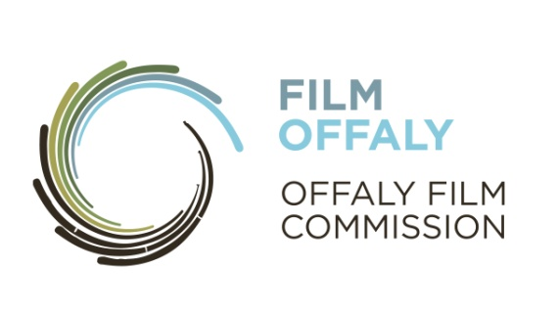

**FILMOFFALY SHORT FILM AWARD 2019**

**Guidelines**

FilmOffaly, Offaly’s Film Commission is pleased to announce the FilmOffaly Short Film Award 2019. This funding initiative aims to foster creative, resourceful filmmaking in the county. FilmOffaly are looking for unique, original stories by talented new filmmakers, professional and novice alike. The only stipulation is that the filming must take place in Offaly!

There will be one award to one successful applicant.

The winning applicant will receive:

* **€10,000** towards the cost of their production.
* **A local premiere.**
* **Mentoring Workshop for Short Listed Applicants**

**Stage One**

Please complete the **FilmOffaly Short Film Award 2019 Application Form** and submit it by post (not e-mail) with **three copies of the script and three copies of a 500-word synopsis** of the film project.

**Omit author and production company names from scripts and synopsis. Just a title and length to show. Only one script per author. Please staple synopsis to front of script. Do not bind or place script in folder.**

It is advised, but not essential, to have a Creative Team/Producer committed to your project before submission as same is essential for Stage 2 of the competition.

Screenplays of shorts films from any genre, style, topic or perspective will be considered and judged on its merits regarding the quality of the material.

**Closing date**: **3pm on Friday 22nd March 2019.**

**Post to: FilmOffaly Short Film Award,** Arts Office**,** Offaly County Council,Charleville Road**,** Tullamore**,** Co. Offaly

**Stage One continued**

* All entries must be post-marked by **Thursday March 21st 2019** in order to be eligible. However, applicants sending entries from European or other countries should allow an extra week for additional postage time.
* Application materials must be in **hard copy not CD.**
* Materials will not be returned unless a correct sized SAE is submitted.
* Do not send originals.
* For your own protection, we advise registering your application with Án Post and copyrighting any material you submit.

**Stage Two**

There will be Four shortlisted applicants, who will be required to do the following:

1. **Attend a Script Writing Workshop** with professional script writers
2. **Submit a Full Production Pack** 
   1. **Notes** outlining intended approach;
   2. **Evidence of ownership of rights**. (Copies of all option and writer’s agreements entered into in respect of story and script if applicable to the project);
   3. **Written confirmation** in the form of clearances and permissions of key subject’s willingness to participate;
   4. **A budget** (to include, production, crew, casting, equip hire, editing, travel, music etc and evidence of further funding)
   5. **CVs of proposed creative team (**director, producer, writer, editor etc)
   6. **Proposed casting** – outline details
   7. **Time schedule**
   8. Any additional relevant supporting materials.
3. **Attend Interview**

It is in the interest of the applicant that as many members of the team attend the interview. Inability to attend for interview will render the applicant ineligible to compete for the award. There will only be one date selected for interviewing.

**Notes for applicants**

**Each applicant must adhere to the following conditions regarding their submissions.**

* The rights of all Screenplays submitted **must be owned by the applicant** in their entirety and be free and clear of any third party interests or encumbrances. The persons and or persons submitting the screenplay must be the author/s of the screenplay and own all its rights in their entirely. (i.e. all screenplays may not have been previously sold, or produced, licensed, optioned or otherwise had any rights transferred to a third party).
* Screenplays must be the **original work of applicant**. Any derivative work - if the screenplay is based upon another work in any medium - must be submitted with proper legal documentation proving that those submitting the screenplay also own the underlying rights or the derivative rights in their entirety. If the screenplay is another person's life story, whether loosely or strictly based, applicant/s must provide a signed statement to that effect by applicant/s and supporting legal documentation verifying that applicant/s has the right to make such an adaptation.
* Screenplays should indicate the duration of the film such as, **10, 15 or 20 minutes**.
* Multiple entries require completion of **separate application forms**.
* Applicant/s hereby understands and agrees that submission does not guarantee that applicant/s will be selected. FILMOFFALY retains sole discretion regarding acceptance issues, terms and regulations, including whether or not any applicant is chosen and a film made.

**Assessment Criteria**  
Applications will be assessed in a competitive context according to the following criteria:

* **The creativity and quality** of the project proposal
* Consideration of the use of **Offaly as a location**
* **The track record of the creative team**
* The demonstrable ability of the team to **complete and deliver** the project with the available funds

For further information and application forms please contact:

**FilmOffaly 057 9357400** [**filmoffaly@offalycoco.ie**](mailto:filmoffaly@offalycoco.ie) **or** [**www.filmoffaly.ie**](http://www.filmoffaly.ie)

FilmOffaly is Offaly County Councils’ Film Commission

